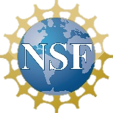

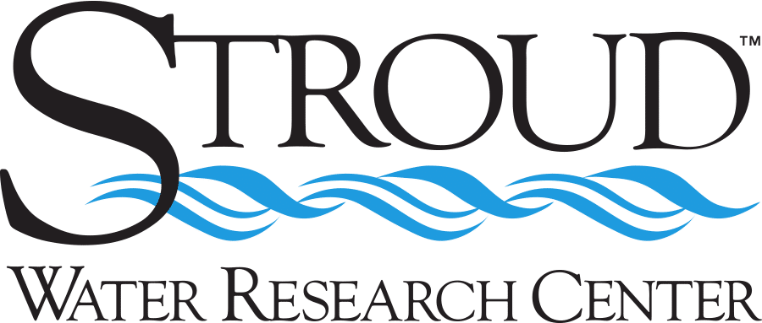

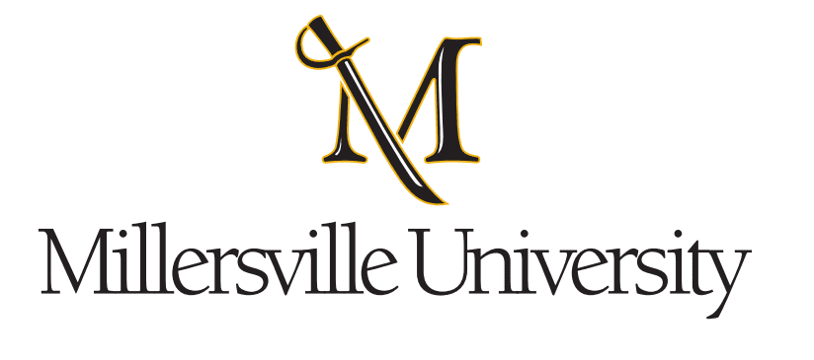

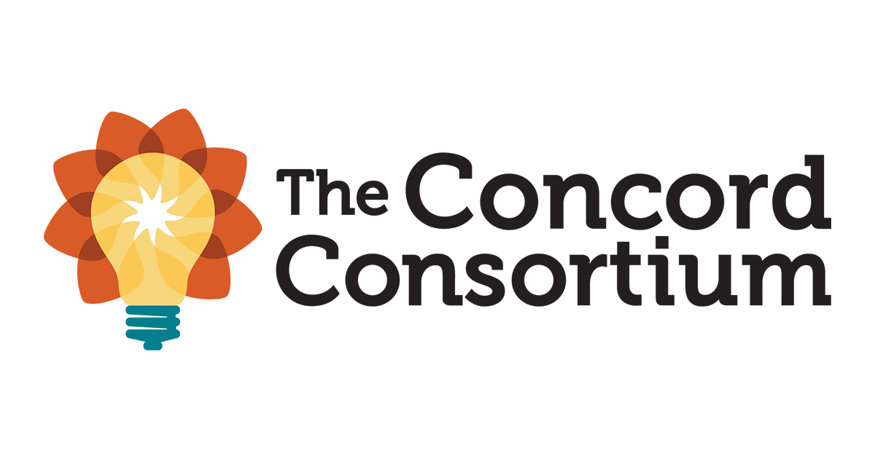

**Equity**

*The project applies principles of Universal Design for Learning (UDL) to create a powerful, scalable approach to watershed learning open to all students. By providing flexibility in information presentation and student responses, reducing barriers in instruction, and providing appropriate supports and challenges, the WATERS project paves a path to increased access to proven curricula and approaches that hold the potential to greatly increase awareness of and engagement with water concepts and career pathways in all learners nationwide.*

**New Challenges & Next Steps**

*During the upcoming year, a final version of the curriculum with UDL features will be made publicly available. 18 Master Teachers from VA, PA, CA, and OR will be selected from the cohort of teachers who implemented the curriculum. They will gather during the summer of 2023 to discuss how best to disseminate the project nationally. The Master Teachers will plan presentation opportunities to share the curriculum with other districts and at the upcoming state and national conferences.*

**Lessons Learned & Insights Gained**

*The results show that ALL students made significant gains in their content knowledge as shown by the statistically significant difference in the students’ mean scores on the pre-assessment (M=9.18, SD=10.58) and the post-assessment (M=12.19, SD=11.08).*

*The UDL features most used by students were scaffolded question hints and the glossary terms while other features such as video closed captions or text-to-speech were only used by a handful of students. Of students with special services, gifted education students used the UDL features more than special education and English Language Learning students.*

*The inclusion of STEM career elements in the inclusive curriculum positively impacts students who enter the classroom with low confidence & efficacy in STEM.*

The research investigates the impact of integrating purposefully designed inquiry, UDL technologies, and career-oriented activities in a diversity of middle school science classrooms.

**Watershed Awareness using Technology and Environmental Research for Sustainability (WATERS)**

Nanette Marcum-Dietrich, Carolyn Staudt, Steve Kerlin

NSF Award Number​: DRL-1417527, DRL-11418133, DRL-141772 Dates: 2019 - 2023

Project type:​ Successful Project Expansion and Dissemination (SPrEaD)

Project URL: <https://concord.org/our-work/research-projects/waters/>

Project Overview: The WATERS project focuses on a single targeted goal: to build, deploy, and research a student-centered, universally accessible curriculum for learning water concepts and water career awareness.