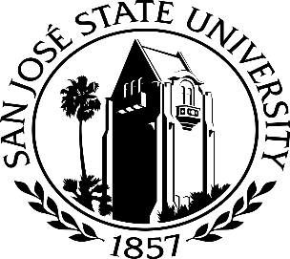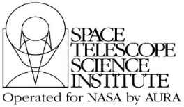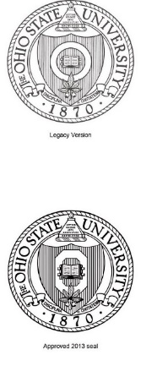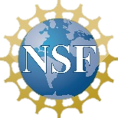

3D Printing technologies, combined with 3D tactile astronomy models and associated lesson activities, can be used to help teach STEM concepts to high school students with visual impairments and help motivate them to pursue a STEM education and career.

**New Challenges & Next Steps**

One problem we are facing is a residual problem due to COVID, namely, low enrollments of students with VI in our in-person summer STEM CEL workshops. This problem is not unique to our project and all summer programs across the nation for students with VI are facing lower than usual enrollments. Our action plan to solve this issue includes earlier and longer advertisement of our summer programs.

**Equity**

We work closely with Teachers of the Visually Impaired (TVIs), numerous state schools for the blind, state agencies for the blind, and students with visual impairments in order to develop STEM lessons/activities and 3D tactile and sound-based models that provide equitable access to STEM content and knowledge for students with visual impairments.

**Lessons Learned & Insights Gained**

Students with visual impairments (VI) have a range of VI, and often other disabilities, and one must accommodate all students. Students with VI often do not have the same life experiences and background knowledge as their sighted peers. A wide range of materials, typically developed from scratch, is needed to accommodate students with VI, e.g. tactile models (2D & 3D), Braille, large print, audio, etc.

**Career Exploration Lab: 3D Printing and STEM Engagement for High School Students with Visual Impairments and their Educators**

Thomas Madura (SJSU), Carol Christian (STScI), Tiffany Wild (OSU)

NSF Award Number​: 1949458 Dates: 2020 - 2024

Project type:​ Developing and Testing Innovations (DTI)

Project Overview: Develop and research STEM Career Exploration Labs (CELs) for high school students with visual impairments around the United States, using astronomy and 3D printing to bolster their interests in and knowledge of STEM and STEM careers.