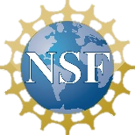

**Equity**

* *Incorporated culture-based learning of each Tribal Nation into design modules, specifically empathic design for elders and 3D scanning artifacts.*
* *Conceptualized culturally appropriate STEM career materials, e.g. parent outreach, video profiles of NA STEM students, and grade-level college and career discussions.*
* *Disseminated directly with indigenous educators at many conferences (e.g. American Indian Symposium, NAU SILS/AIITEC, AISES, NIEA Conference and Educator Day)*
* *Hosted hack-a-thons to promote intergenerational learning about new technologies.*

**New Challenges & Next Steps**

* *A new challenge is the incorporation of Tribal cultural and historical knowledge into our lessons and designs due to the availability of information from the Nation.*
* *One focus for the next year will be on developing an age-appropriate measures of spatial thinking suitable for 3D learning environments.*

**Lessons Learned & Insights Gained**

* *Tribal Nations vary in their levels of traditionalism concerning (a) sharing historical and cultural knowledge with outsiders and (b) attitudes about the use of new technology.*
* *Following a DBR process allows for improvements in quality and effectiveness of module lessons each semester.*
* *It is important to be flexible in working with the Tribal Nations, e.g. adjusting implementation due to limited staff and time constraints in the afterschool setting.*
* *Creation of 3D objects was the biggest motivator and confidence builder for students.*

**Engaging Native American Students in STEM Career Development through a Culturally-Responsive After-School Program Using Virtual Reality Environments and 3D Printing**

Authors: Tilanka Chandrasekera, Nicole Colston, Tutaleni Asino, Cynthia Orona

NSF Award Number​: 2048987 Dates: 2021-2025

Project Type:​ Developing and Testing Innovations

Project URL:  www.namsas.net

Project Overview: This project designs and pilots spatial design activities using Virtual Reality (VR), Augmented Reality (AR), and 3D printing with middle school students in 3 Tribal Nation afterschool programs.

Culture-based science learning leads to meaningful intergenerational learning about the role of new technology in society and wok.

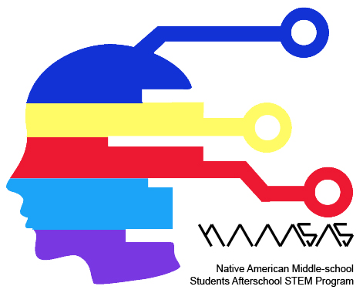Add

additional

logos here

Add

additional

logos here