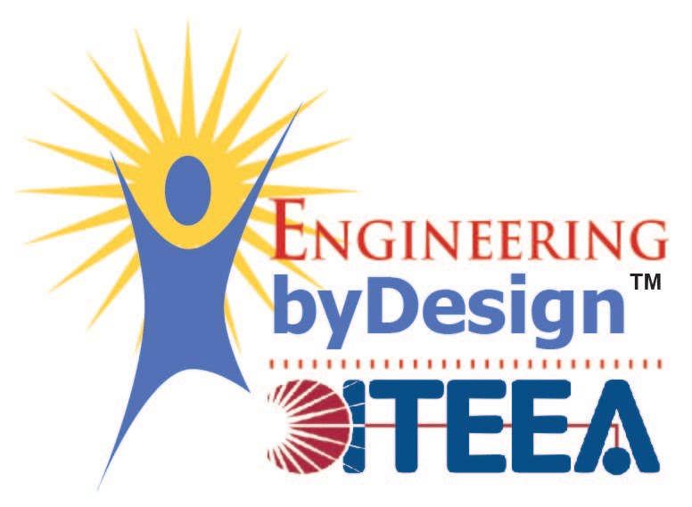

**New Challenges & Next Steps**

*Recruitment of teachers proved to be more challenging than anticipated. We changed our recruitment strategy and spent more time to 7 recruit teachers with diverse classrooms in Indiana. We have conducted two professional development workshops for teachers in Indiana. Next year, teachers will implement the Neu-pulator lesson plans in the classroom. In addition, we decided to start implementation with one teacher in Georgia in preparation for next year’s plans to engage the Dekalb district in Georgia.*

**Equity**

*Students engage in meaningful societally beneficial design work in the context of assistive technologies. Learning experiences are scaffolded to make them accessible to all students.*

This is the **main takeaway** from your research to date. It should be **simplified** to one or two sentences.

**Lessons Learned & Insights Gained**

*This year we focused on the development of lesson plans and teacher professional development training material. Significant effort was dedicated to developing reliable user-friendly robot-kits for classroom based early implementation feedback. We also developed a website for teacher engagement where the lesson plans and supporting materials will be available.*

**Co-Robots to Enhance Motivation and Self-efficacy in Formal STEM Education**

Nina Mahmoudian, Mo Rastgaar, Nathan Mentzer, Ryan Novitski

NSF Award Number​: 2133028 Dates: 2021-2024

Project type:​ Developing and Testing Innovations (DTI)

Project URL: <https://robot-school-465d1.web.app/>

Project Overview: The central focus of this research effort is to identify the potential impacts of positioning the student as a co-roboticist in the context of design thinking. This project presents Neu-pulator, Neurally Controlled Manipulator, an innovative collaborative robot that helps students to learn about mechatronics, programming, human-machine interface, and biomechanics.