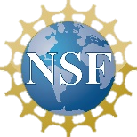

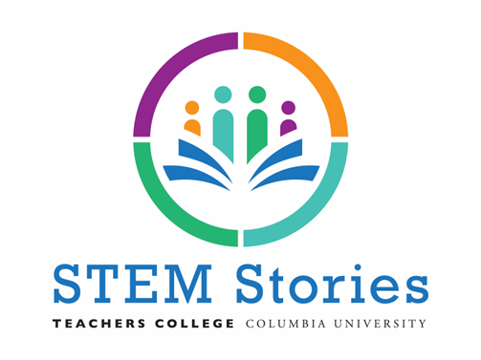

**New Challenges & Next Steps**

Need to Reconsider: Methods for engaging with teachers and data collection during a pandemic

Creatively Overcame: Digitalized all of our professional development resources. Online data collection allowed us to secure interviews from parents who had no time to come for in-person interview

The Year Ahead: Working to co-construct new lesson plans with teachers in partnering schools

**Equity**

The professional development we provided to our partnering schools:

– Developed a STEM Stories lesson Plan website, which included resources on culturally responsive teaching, with Spanish translations of lesson plans and other material;

– .Offered weekly STEM Stories teacher support sessions with one of the partnering schools and monthly meetings with science teachers at the other school during 2021-22 school year.

– Offered virtual PD session to both schools in which the tie between the project and culturally relevant teaching approach was emphasized.

**Lessons Learned & Insights Gained**

- Helped connect the STEM knowledge in students’ homes and communities to their school curriculum

- Enabled the teachers and administrators in our partnering schools to become more culturally responsive and antiracist in their approach to teaching STEM, and

- Brought to light the knowledge, voices and experiences of family members, thereby broadening students’ understanding of STEM and boosting the STEM efficacy of many students.