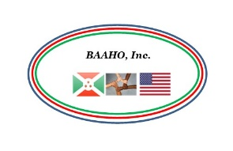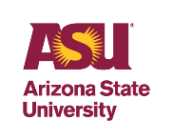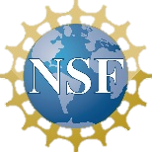

Our efforts have positive effects on students and parents of refugee backgrounds, including their understanding of college navigation, STEM capital, and STEM identity.

**New Challenges & Next Steps**

*Variation in the types of community organizations can be challenging. Organizations range from loose associations of individuals to cohesive establishments with multiple funding sources. This leads to the need to be adaptive with relationships to build partnerships and not treat community organizations using one-size-fits-all approach*

**Equity**

*Leaders from Burundian, Congolese, Somali, and Syrian communities facilitate “college knowledge” activities, which they adapt to their needs, and assist faculty with delivery of STEM Activities. Community leaders interpret on-the-spot for family members still learning English, directly recruit families to participate, and identify mentors from their communities to work with high school students.*

**Lessons Learned & Insights Gained**

* *Involvement of community leaders during all steps is critical*
* *Empathy is beneficial, pity is not*
* *Cultural identity and heritage, especially as it relates to education, is a compelling force*
* *Community engaged research requires long-term commitment*

**Promoting Aspirations in Science, Technology, Engineering, and Mathematics through Youth and Family Engagement**

Eugene Judson, Meseret Hailu, Mohammed Ibrahim

NSF Award Number​: 2045306 Dates: 2021-2024

Project type:​ ITEST

We are working with local refugee communities to promote STEM aspirations among students in grades 7-12. We are accomplishing this by having parents and their children engage in multiple activities including workshops focused on both STEM careers and college navigation, campus field trips, e-mentoring, and digital storytelling.