



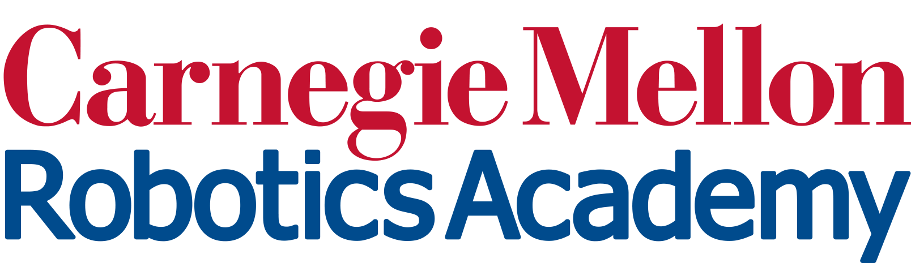

Instructor diversity will be a central challenge in making “convening” work. Legacy “data lakes” are still hard to tap, but hold diminishing relevance as content evolves.

**New Challenges & Next Steps**

* Use data collected over the summer to train the first full model
* Scale database architecture to permit real-time student model test
* Co-design Convening UX with teachers, referencing app notification models
* Literature search for few-shots methods to “tune” the tool for teachers’ styles

**Equity**

* Classroom data collection intentionally sampled from diverse schools, e.g., urban public schools and private suburban academies
* Offered free summer programming course to 36 learners online. Opt-in data collection contributed 953 sessions to the Y2 training corpus.

**Lessons Learned & Insights Gained**

* Legacy simulator drift precludes use of archival code for model training. Modern simulators have been more fruitful.
* Teachers employ qualitatively different troubleshooting routines in class. The system may have to adapt to teacher styles.

**Lessons Learned & Insights Gained**

**Using AI to Focus Teacher-Student Troubleshooting in Classroom Robotics**

Ross Higashi, Jean Oh, Emily Byun, & Leo Chen

NSF Award Number​: 2118883 Dates: 2021-2024

Project type:​ RETTL (Research on Emerging Technologies for Teaching and Learning)

Project URL: https://www.cmu.edu/roboticsacademy/Research/facilitate.html

Project Overview: We are investigating a “convening AI” that brings together teachers and students to troubleshoot around machine-selected excerpts of student work-in-progress. Our initial domain is middle school virtual robot programming.