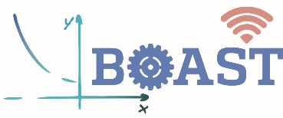Center for Educational Outreach

**New Challenges & Next Steps**

* The program will begin with a longer on-ramp, with family-focused open houses, and in early sessions, students will receive explicit instruction on time management and help-seeking strategies. Benefits the program confers will also be reinforced (e.g., preparation for college, info about STEM-career earnings, recommendation letters for college applications).

**Equity**

* Many students in Baltimore City Schools lack access to STEM-focused enrichment opportunities, particularly those in under-resourced schools targeted by BOAST. Through BOAST, more students are being exposed to engineering content and careers and gaining needed practice with fundamental algebraic concepts.
* Students are particularly receptive to videos of STEM professionals who share their characteristics and experienced similar challenges during formative years.

**Title: Baltimore Online Algebra for Students in Technology (BOAST)**

Michael L. Falk; Alisha Sparks; Rachel E. Durham; Emily Yanisko

NSF Award Number​: 2005790 Dates: 2020-2024​

Project type:​ Exploring Theory and Design Principles (ETD)

Project URL: https://engineering.jhu.edu/outreach/get-involved/baltimore-online-algebra-for-students-in-technology/

Project Overview: BOAST is an out-of-school time online engineering program to support

Baltimore City high school students develop concrete goals of becoming engineers by supporting foundational math skills and math self-efficacy through hands-on design and application.

Succeeding in an asynchronous program requires students to have developed college readiness skills, particularly time management, communication, and self-management.

**Lessons Learned & Insights Gained**

* Although asynchronous programming is resource-efficient, the social components of learning that high school students gain through peer collaboration, on-site activities, and direct instructor interactions are essential.
* A potential solution to the ethical challenges of participant randomization is *a priori* school matching on predictive characteristics.