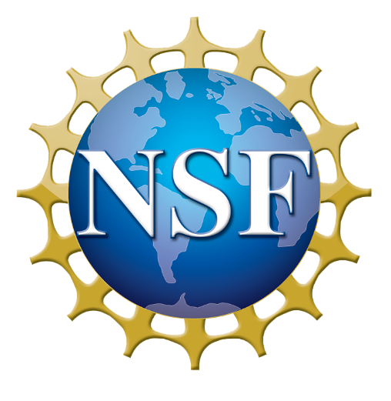
Narrative Modeling with StoryQ
Jie Chao, Concord Consortium
NSF Award Number: 1949110
Project type: Developing and Testing Innovations (DTI)
Project URL: https://concord.org/our-work/research-projects/storyq/
Dates: 2020-2023
Project Overview: StoryQ’s mission is to integrate mathematics, language arts, and computing to create pathways to AI careers

Lesson Learned & Insights Gained

- StoryQ app allows learners to engage in machine learning practices and work with unstructured text data without coding
- Text data creates opportunities for collaborative learning and engaging discussions
- Non-STEM teachers’ self-efficacy in learning and teaching AI increased after discipline-specific PD workshops

Equity

- Learning of innovative ML/NLP-based technologies by underserved schools and non-STEM classrooms
- Learners from underrepresented groups used their own backgrounds as unique resources to reason about language use in diverse contexts

New Challenges & Next Steps

- The tension between learning of ML practices and other disciplinary practices
- Investigate student learning in different non-STEM classrooms

