

**New Challenges & Next Steps**

Our goal is for participants to use this process to create a shareable resource to be presented in Jan 2023. The open-ended and non-prescriptive nature of this problem has proved a challenge for our teams, and we are working to scaffold their learning and prepare them for a meaningful presentation and project output.

**Equity**

The professional learning objectives were co-created with the returning participants who brought new team members during the fourth summer institute. We modeled using a human- and empathy-driven design process to both equip and train participants to employ the same skill in creating equitable and inclusive STEM learning environments for their students.

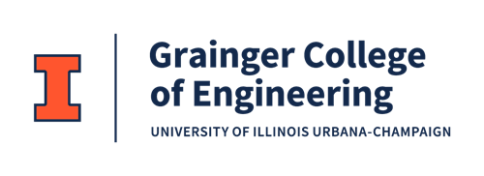

Time, context, and content usability presented barriers to overcome when implementing afterschool STEM Club opportunities; but a focus on equity and inclusion strategies in STEM Club implementation was accompanies by increased diversity of club participants.

**Lessons Learned & Insights Gained**

Based on focus group reflections from participating educators, a year was insufficient to have the impact they had hoped for in their schools. Because of this, our fourth year (no-cost extension) has taken a different approach than years 1-3. Instead of focusing on recruiting a new cohort, we invited participants from previous years to extend their learning and expand their school-based collaborative teams. This simultaneously supports our goals for enabling sustainable impact while also allowing school-based teams to take greater ownership in the equitable and inclusive environments they create for their students.

**Catalyzing Inclusive STEM Experience All Year Round (CISTEME365)**

Lynford Goddard, Lara Hebert, Luisa-Marie Rosa, Lorenzo Baber, Meagan Pollock

NSF Award Number​: [1850398](https://www.nsf.gov/awardsearch/showAward?AWD_ID=1850398) Dates: 2019-2023

Project type:​ Developing and Testing Innovations

Project URL: <https://cisteme365.engineering.illinois.edu/>

Project Overview:   
The CISTEME365 project headquartered at the University of Illinois Urbana-Champaign hypothesizes that experiences with cutting-edge technology must exist all year-round to effect significant improvement. Thus, the fundamental project goal is to enable middle and high school Underrepresented Students (URSs) in STEM (female, underrepresented minority, and/or low-income) to participate in sustained, intensive, hands-on STEM learning experiences. The CISTEME365 project investigates the synergistic effects of school-year STEM clubs, university-hosted summer camps, and a summer learning institute combined with a school-year networked improvement community (NIC) for school counselors and teachers.

