Wrong Theory Protocol Facilitation Guide
Created by Vanessa Svihla, PhD. vsvihla@unm.edu
Note: there are two primary ways to use the Wrong Theory Protocol:
- As a pre-ideation technique with a group that is already engaged in a design process
- To teach people the technique, such as at a workshop
In the former, they should already have gathered information about the problem. In the latter, you will also need to scaffold attendees to frame a problem. Problem framing is difficult and unfamiliar work for many, so please see the quick problem framing guide in the appendix and pay attention to notes below. Also note that for some groups, extra time may be needed for building trust and taking up the role of change agent.

Set the expectation for generative activity
Facilitator introduces self and shares an example of bad design they are responsible for.
Explain:
A great deal of insight can come from failure. Bad design helps clarify our values and needs when they are unmet.
Facilitator asks participants to each share an example of bad design—if they are willing, share something they designed, but it is okay to just share bad design they have encountered. For large groups, ask them to do this with near neighbors. For small groups, share with room.
Allow time for this, as it sets the tone for the rest of the experience and builds sense of community.

Set the purpose of wrong theory
Facilitator explains:
Often, when designing, people get stuck. They have trouble coming up with new and good ideas or they get fixed on their first design idea. Today, we’re going to try a technique called Wrong Theory. It might seem a little silly or wrong at first, but that’s okay. The purpose of the activity is to help you really understand the problem and to see it from a different point of view.
Often, our first design ideas are not the best, yet they can stop us from thinking about creative ways to address the problem. Designers use ideation—a word that comes from combining “idea” and “generation” to come up with new ideas. However, in our experience, and in the research literature, when we ask people to generate ideas, they often simply come up with flawed versions of their initial idea, which makes ideation busy work. Or, they get fixated on existing solutions without even realizing it. Instead, we are going to try wrong theory first, before you do a more traditional ideation technique.
As designers, we value both creative and empathetic designs. Design thinking encourages us to use empathy, but most empathy techniques tunnel our vision, encouraging us to focus on just one person’s experience.
In past uses of wrong theory, we have found that wrong theory works for several reasons. First, the pressure to have the “right” idea can prevent us from having good and great ideas. Wrong theory removes this pressure. Second, wrong theory helps us notice things about stakeholder experience and about the problem that we might not have missed. Third, after coming up with harmful and humiliating ideas, we feel beholden to stakeholders and commit more strongly to meeting their needs in empathetic ways.

Frame the problem
Wrong theory is only useful if there is already a problem. When giving workshops on wrong theory, the facilitator should assess the likelihood that participants will be able to quickly identify and frame a problem that they have influence over. Problem framing is difficult and unfamiliar work for many. Even if you are confident in participants’ capacity to bring such problems to the workshop, keep in mind that they may not be able or willing to share information about their problem with others. For that reason, it is helpful to be ready with (1) tools for framing problems (see handouts for problem framing in Appendix A) and (2) 1-page design briefs for problems that are relevant to your audience and/or low-bar entry, making them easy for participants to understand and engage with (see example design briefs in Appendix B and C). You should either adapt these or create your own brief to ensure the problems appear authentic. These should not be toy or fake problems, but instead, should be presented as unsolved problems that you are asking participants to help define and solve. See Appendix D on facilitating problem framing.
Remind participants that as designers, they are responsible for framing the problem, and that there are many different ways to frame any design problem. Provide the handout for briefly framing the problem (Appendix E). It is helpful to give each participant their own handout and to ask them to work individually, as this can sometimes illustrate that even when working on the same problem, there are multiple possible frames. Explain:
I’d like you to take just 10 minutes or so to review the design brief and answer the questions on your own.
Give a 2-minute warning to keep the pace going.

Trust-building + Positioning as change agents
This section may or may not be needed. When working with teachers and groups/problems focused on diversity, equity, and inclusion, it should generally be included.
In past uses of wrong theory, we have observed that it works well when people engage playfully. However, some people feel uncomfortable in the process.
WTP works for many different problems and groups, but it is dependent on your role and your engagement. Researchers have found that if your role makes you feel responsible for some form of oppression, you may feel less able to change it, or you may feel defensive. It is not uncommon in this WTP process for participants to realize that their current practice is humiliating to those they serve. Today, if you find yourself feeling this way, if you realize some part of your practice already causes some harm or humiliation, I want you to do the following: First, acknowledge that structural oppression is coercive and ubiquitous. Structural racism, sexism, and classism are difficult to resist. But today, instead of wallowing in blame, becoming defensive, or feeling helpless, I want you to own your role as an agent of change.
This is similar to bystander training. Research shows that if a sexual harassment prevention training only positions attendees as aggressor or victim, the training can backfire, but if attendees are invited to take up the identity of bystander, it can help change attendees’ behavior. I want you to be more than a bystander. I want you to be an agent of change.
Some people may feel uncomfortable coming up with terrible ideas. We bring diverse life experiences to the table today. As we propose harmful and humiliating ideas, we do so only as a commitment to coming up with more empathetic ideas and being change agents.

Generate harmful and humiliating ideas
Now that you have thought about the problem, I want you to come up with a design that violates these and addresses none of the needs. The point is not to come up with a lazy design, but one that really is horrible. Come up with something that is worse than no design at all.
For instance, imagine you are designing a doghouse for a small dog. A lazy design would be one that the dog can sit in, but is too big, and has a roof that is not well sealed. It is still better than no doghouse. A horrible design would be one that has a roof made of sprinklers, a bed of spikes, and an audio loop that plays, “Bad dog!” in a voice the dog will recognize. It would be worse than no design at all. A terrible design should both harm and humiliate!
Some people may feel hesitant or uncomfortable about doing this, but it will help you understand the problem. Remember to engage playfully! Spend about 15 minutes, and be ready to share your horrible design and defend why it is the absolute worst. You may work alone or with others.
Circulate while they work. You’ll likely find that some people are not coming up with horrible ideas. You may need to check their list of needs to help them think about how they are violating those needs. The goal is to really get them to be a bit silly, to get into it. Some will come up with injurious ideas quickly, then stop working. Ask them to add humiliation. Keep it lively with “Well, that’s bad, but is it really the worst?”
I’d like to hear about some of your horrible designs. When you share, help us understand why your idea is the absolute worst. Let us know how you design violates a constraint or avoids addressing needs.
Have at least 3 people share.

Generate beneficial ideas
Now that you have come up with truly horrible designs, it is time to come up with beneficial ideas. I want you to stay tentative and try to come up with a few really different ideas. Don’t focus on trying to get the best idea. Instead, try to be open and generative. Suspend judgment: don’t discount or eliminate any ideas at this point. Try to come up with different ways to meet the needs you identified, not just minor variations of the same solution.
Give them ~15 minutes or so to generate ideas. Again, ask a few participants to share their beneficial ideas.
Ask whether anyone noticed something about the problem they had not previously thought about.

Reflect
Reflection is an important part of the learning process. Whether participants are learning about the problem or how to do the process, reflection deepens the learning.
Provide a handout (Appendix F) to guide their reflection.

Appendix A: Handout for problem framing
Modify the example highlighted text to adapt it to your context and the field(s) of your participants. Print on both sides. See facilitation guide in Appendix D.

Problem framing tool: Problem statement + 5 Whys
Problem statement. Describe a problem related to your work on your campus or in your community, biomedical engineering, community planning, instructional design. You must have some influence over it and be knowledgeable about it. What are the specific issues and impacts? Include who, what, when, where and why.

Five whys. Repeatedly ask and answer “Why does this happen?“ Provide detail and remember to consider diverse perspectives on the problem. Focus on behaviors that contribute to the problem. Try to identify more than one cause. See example on reverse.

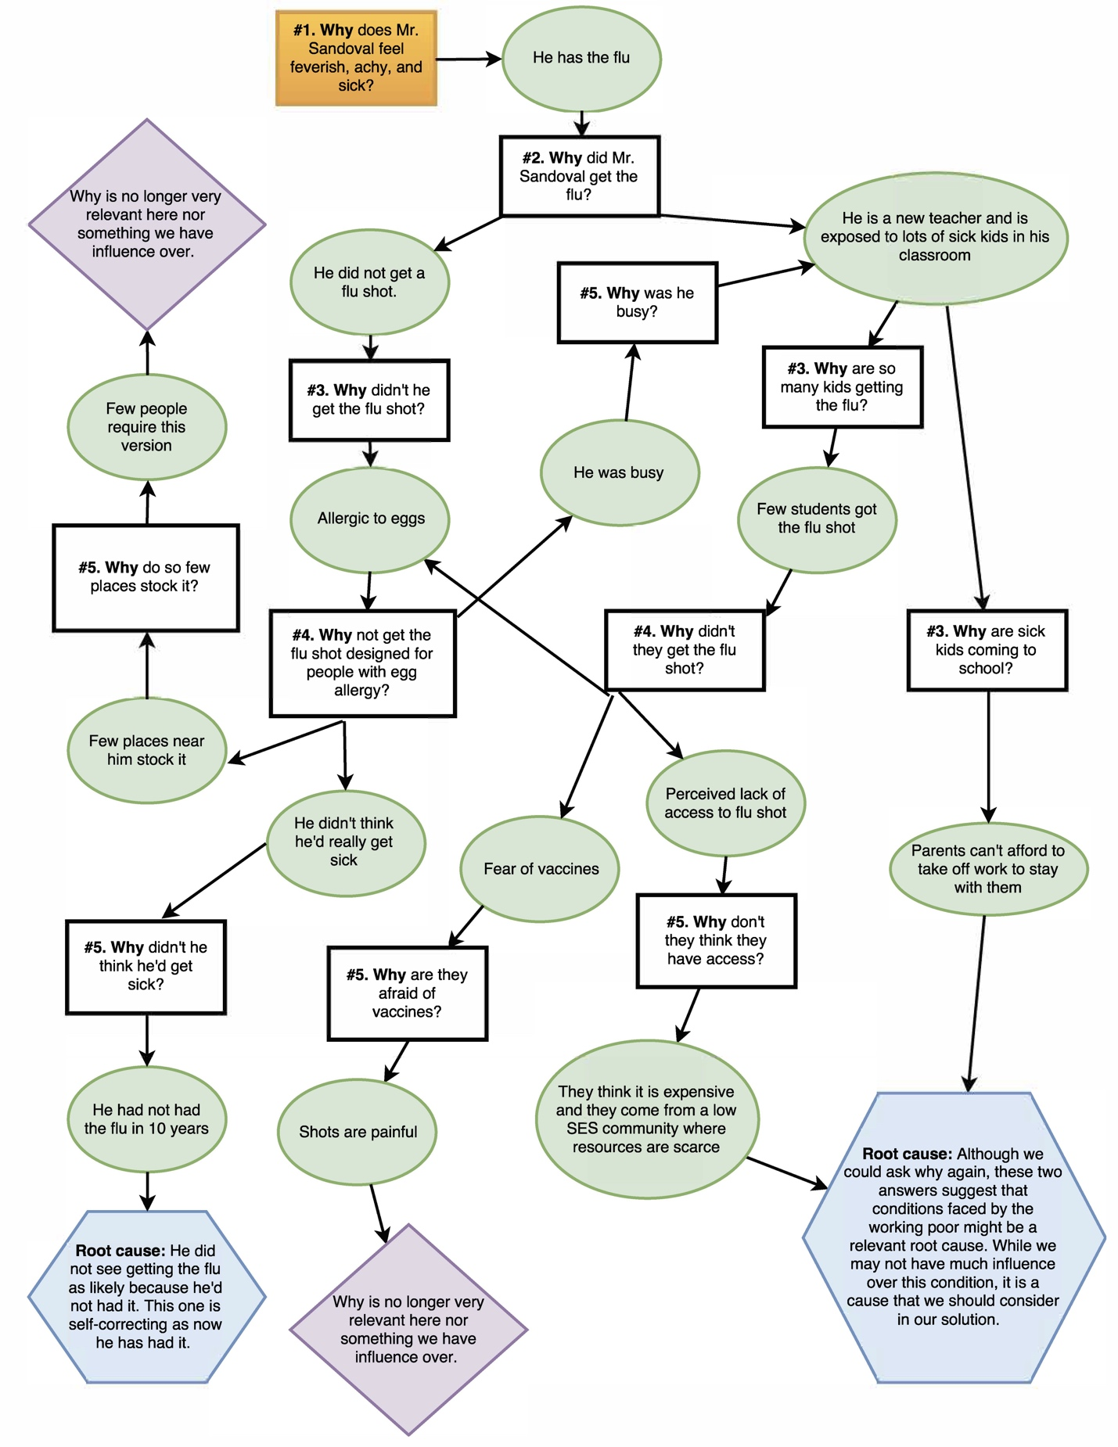

Appendix B: Problem Framing Resource: Hypermobility Design Brief

Design brief
Patients with hypermobile joints commonly have trouble with everyday tasks that present no challenge to the general population. Hypermobility results in increased flexibility. Patients commonly have decreased strength and are susceptible to injury from common activities due to instability. While physical therapy may be used to prevent or heal injury, many patients require support during therapy or have chronic injuries that do not improve with therapy. Assistive devices exist for activities that present challenges to the geriatric population, such as opening jars and cans. However, a range of everyday activities present challenges for those with hypermobility in the wrist and lack adequate assistive devices (Table 1).
Table 1. Common tasks that present challenges to patients with wrist hypermobility
Task | How those with stable joints typically accomplish task | How those with hypermobility in the wrist typically accomplish task
Opening doors that require force applied while turning a knob or a key | One hand smoothly turns knob or key while applying force | Two hands, one turning and one gripping, both applying force. Once initial opening accomplished, patient will quickly shift to hip, shoulder or foot to apply force. Multiple attempts common.
Opening heavy doors that require force applied as a push to the door itself | One-handed with a flat-palm push | Two handed, with fingers extended straight and locked, or with hip and shoulder push.

We have included transcripts of interviews with our customer pool describing their experiences:
“I feel like something is going to snap in that spot where my palm meets my wrist every time I open my office door. I have to turn the key from vertical to horizontal as I push the door. I usually use my foot to give it a good shove once I get the key turned.”
“I do [physical therapy] exercises every day, but there has been so much damage, there is only so much the exercises can help with at this point. My biggest challenge is probably new-to-me doors. You never know how heavy a door is, that is new to you, how much you’ll have to twist your wrist around to get it open, how much you’ll have to push. Every new door is a full-body problem to solve. I have to have my hip and foot and shoulder ready, ‘cause I never know what it’s gonna take to get it open. And if I have anything in my hands—like a cup of coffee, it’s probably better to just wait until someone else goes through the door and slip through after them, using my foot to catch it if needed, ‘cause I certainly don’t want to rely on my wrist for that.”
“I have this brace I can wear, but it draws attention. I want to look normal. So I never wear it.”

Appendix C: Problem Framing Resource: Welcoming Campus Design Brief

Design brief
During recent accreditation procedures at Southwestern Research University (SRU), we face pointed criticism: Although we boast about being a Hispanic serving institution, we do not have Spanish language anywhere, and our campus is not welcoming to those who do not speak English.
While we do not have the capacity to provide diverse degree programs physics, theater, and mathematics in Spanish, we know we have many students whose families do not speak English. When they come to campus, they have difficulties finding their way, and are sometimes uncertain if they are welcome on campus.
We collected and translated quotes from family and community members who do not speak English to better understand their perceptions of SRU’s campus:
- My grandson is a student at SRU in biology. I feel very proud of him because he is the first person in our family to attend college. He invited us to campus for his poster presentation, but because his mother and my husband were working, I was the only one who could come. I felt so ashamed because I could not find the building and I missed it. I walked from building to building, but I could not find it. –Roberta (Spanish speaker, family member)
- I went to SRU to just walk around and see the campus, but then I was trying to find a restroom on campus and figured most buildings would have one, but because I am not student-aged, I felt like everyone knew I didn’t belong. I didn’t know who to ask. I left and found a store off campus. –Thanh (Vietnamese speaker, community member)
- I was visiting from a German university to do collaborative research. I decided to try to find the German department to see if I could talk to students and maybe volunteer in a class for a few weeks. I know I should speak English, and younger Germans certainly do, but in my generation, we did not learn it well in school. I think I found the right building, but I could not find the office, and I could not figure out who to ask. I was too embarrassed and decided I would just focus on my research collaboration. I gave up, and mostly stayed in the building I was doing my research in. –Helmut (German speaker, foreign visitor)
- My niece told us about a flamenco performance at SRU, and I wanted to go see it. She told me when and where to meet her, but I was a couple minutes late because of an accident at the Big I. I couldn’t tell where I was allowed to park, and I ended up even later. And then I was all lost and felt everyone staring at me. I got back in my car and went home. –Gabriela (Spanish speaker, family member)
- I have lived near campus my whole life, but never visited SRU. My new job has me making deliveries sometimes, and the company owner just borrows a big white van from his cousin, so it does not look like a typical delivery van. I had to deliver a box to SRU, and that place is confusing. I didn’t know who to ask for directions and everyone was staring at me. They knew I didn’t belong. I was late by the time I got the box delivered. –Jorge (Spanish speaker, community member)
SRU would like your ideas for improving this situation. Keep in mind that cost effective solutions are more likely to be implemented.

Appendix D: Quick Problem Framing Guide
Explain:
Design problems are different from other types of problems. They don’t have a single right answer, but instead have many possible answers.
Inexperienced designers tend to jump straight to solutions because so much about our education and workplaces encourage this. Experienced designers dwell with the problem. They spend time with its ambiguity and take plenty of time to understand it. They try to see the problem from different stakeholder points of view. I’ll be reminding you to stay with the problem.
If you have a problem in mind, use the problem statement and five whys approach to frame your problem. I encourage you to invite others to work with you.
If you don’t have a problem in mind, I will also give you a design brief and I’d love to have you work on this problem.
Take time to explain the problem in the design brief and to emphasize the authenticity of it as an unsolved problem.
Circulate and when you hear solutions, remind them to stay with the problem.

Appendix E: Handout for Framing the problem

Conceptual Design Deliverables

Stakeholder needs
What needs will your design solution address?

Constraints & design requirements
What constraints do you need to attend to?

Problem definition
Briefly describe the design problem you are trying to solve.

Appendix F: Harmful & Humiliating ideas handout

Wrong theory design
Look back over the needs, constraints and requirements you identified. Now violate these! Your task is to come up with the worst possible design, one that violates constraints and does not address needs. It should both harm and humiliate.
- Sketch and label your ideas below.
- Be ready to share your design and defend why it is the absolute worst.

Generate beneficial ideas
Don’t focus on trying to get the best idea. Instead be open and generative. Suspend judgment: don’t discount or eliminate any ideas at this point. Try to come up with different ways to meet the needs you identified, not just minor variations of the same solution. Here are a few ways to come up with ideas:
- Think about the category of the problem you are solving and then investigate how others have solved similar problems. For instance, if you need to come up with a way to close a cat carrier, do a google image search of lids to get ideas. But don’t get stuck in what others have done.
- Try role playing. Imagine you are the stakeholder. What do you want?
- Sketch lots of ideas freeform. Use stick figures or simple diagrams, not detailed pictures.
Document your ideation process.

Appendix G: Reflection handout

Reflect and plan
Can you share a little about how you felt as you went through the process, from defining the problem, to posing harmful & humiliating ideas, to coming up with beneficial ideas?

Do you think coming up with ideas that could harm and humiliate changed your understanding of the problem? If yes, how? If no, why not?

Did coming up with harmful and humiliating ideas help you be more creative? If yes, how? If no, why not?

Did coming up with harmful and humiliating ideas help you be more empathetic? If yes, how? If no, why not?

How will you use the Wrong Theory Protocol in the future?

