Math in the Making: Reflections for the Field
InformalScience.org Blog Post 2017
Authors: Scott Pattison, Andee Rubin, Tracey Wright

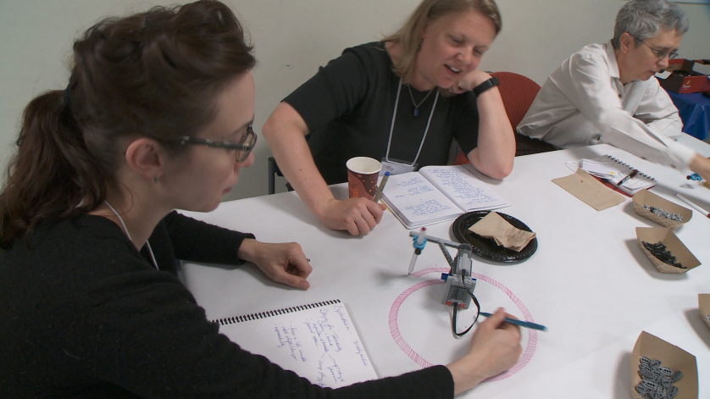
Mathematics is foundational to all fields of science, technology, and engineering (NCTM, 2000; NRC, 2012) and has been shown repeatedly to be a gatekeeper for long-term engagement with STEM topics and careers (e.g., Dika & D’Amico, 2016; McCreedy & Dierking, 2013; Staus et al., 2016; Turner, Steward, & Lapan, 2004). Although there is a growing body of research on mathematics in informal learning environments (Pattison, Rubin, & Wright, 2016), little has been done to understand how math can be integrated into other informal STEM education settings or topics, and how this integration might engage those who do not already have positive attitudes about math. One area of particular promise for exploring this integration is making. Over the last decade there has been a proliferation of out-of-school environments that foster building, making, tinkering, and design (Bevan, Gutwill, Petrich, & Wilkinson, 2015; Vossoughi, Escudé, Kong, & Hooper, 2013), creating an unprecedented opportunity to engage a wide range of participants in mathematics that is both purposeful and powerful.

In September 2015, with support from the National Science Foundation (DRL-1514726), TERC and the
Institute for Learning Innovation launched the Math in the Making project to engage the field in discussions about the relationships between mathematics and making and, in particular, to consider how integrating the two might both enrich making experiences and support mathematical learning and interest development for children and adults. The collaboration included a national workshop with leaders from informal education, mathematics, and making and tinkering; a pre-workshop online discussion; a synthesis of literature on mathematical reasoning outside of school; and a website (mathinthemaking.terc.edu) with video highlights of the workshop, reports from workshop discussion groups, and other related resources. One year later, we take this opportunity to share emergent themes and recommendations for the field.
“It's very important for us to identify, value, and foster rich STEM thinking in our exhibits, activities, and programs. On the other hand, I want us to do that in an authentic way—I want the mathematical reasoning to genuinely be a part of the making activity, not an add-on or overlay. I'm curious about how deepening the math can authentically enrich the making.” – Workshop participant
Emergent themes
The topics of the online and in-person discussions were wide ranging, highlighting the diversity of goals and perspectives represented by participants. Nevertheless, several themes with relevance to the informal STEM education field emerged from the conversations.

Balancing the goals of math engagement and making
Our discussions surfaced a tension between (a) the value of highlighting the mathematics in making and tinkering experiences and (b) concerns about compromising the essential qualities of making as an agentive, unconstrained activity. A key question that emerged from the discussions was how to promote math learning and reflection without detracting from the freedom inherent in authentic making experiences. One promising approach suggested by participants is to find compelling making activities that naturally require mathematics and provide learners with tools to enhance and support mathematical thinking. Rather than seeing math as an add-on to a making activity, we need to work with examples where mathematical thinking is consequential to the task. Participants noted that more research is needed to explore how mathematics should be framed in integrated math-making activities, and how this framing might influence the experiences for participants. How explicit should the mathematical content and goals be? Should they be introduced at the beginning of an experience, throughout, or only afterwards?

Navigating negative perceptions of mathematics
One of the primary reasons we launched Math in the Making was our recognition of the widespread negative perceptions of mathematics shared by adults and children alike (Pattison et al., 2016). These negative attitudes have important implications for how individuals relate to STEM topics, come to see themselves as STEM learners, and consider pursuing STEM-related careers (e.g., Dika & D’Amico, 2016; McCreedy & Dierking, 2013; Staus et al., 2016; Turner et al., 2004). Workshop participants discussed how making experiences, which have been shown to have broad appeal (Vossoughi & Bevan, 2014), could be leveraged to help change mindsets and beliefs about mathematics. On the other hand, negative attitudes present challenges to integrating mathematics and making, since participants might react differently to a making experience that they see as involving mathematics, or choose to disengage when the mathematics becomes central. Again, answering questions about how mathematics is framed is important to help the field move forward.

Addressing issues of equity and diversity
During the workshop, Marta Civil from the University of Arizona and Paula Hooper from Northwestern University gave inspiring and provocative talks on the ways in which equity and diversity relate to the integration of math and making. Both presenters highlighted the importance of understanding that making is not a new endeavor. Historically, many communities have engaged in making out of necessity (e.g., designing and sewing clothing, building and repairing furniture, etc.), not as an extra-curricular hobby. Adopting a “funds of knowledge” perspective (González, Moll, & Amanti, 2005) requires that we discover and honor the mathematical and making skills that already exist in communities. Thus, creating integrated math-making experiences that support engagement and learning for diverse audiences will likely require a two-way dialogue: (a) designing compelling making experiences to introduce important mathematics and (b) finding and highlighting the mathematics that already underlie making activities inside and outside educational spaces.

Conceptualizing mathematics broadly
A broad view of math—including the many subfields of mathematics, mathematical reasoning, habits of mind, dispositions, and identities—is necessary in order to see and support opportunities for math in making. The mathematics most people encounter in school provides a woefully limited view of the topic’s potential richness, focusing mostly on numbers, computation, and solving equations. While the majority of project participants agreed with this broad definition, they also highlighted the challenges for non-mathematicians trying to identify the mathematical potential in a given making activity. Participants emphasized the importance of grounding ongoing discussions in a deeper understanding of content and of reasoning practices specific to mathematics, in contrast to those that apply to multiple disciplines. These challenges connect to issues of equity and inclusion, since the way mathematics is defined can have important implications for learners and communities.
“We needed more time to talk about math and math practices. It is difficult to think about designing spaces and supporting math without a deep understanding of the topic. Even the way the mathematicians and the math educators approached math was quite different.” – Workshop participant

Finding the math in making, or the making in math
There is a difference between (a) starting with a making experience and looking for the potential mathematical connections (“math in making”) and (b) designing a making experience with mathematical content in mind (“making in math”). Workshop participants shared examples and approaches from both perspectives and discussed trade-offs between the two. There was a concern that although an activity designed from the outset around mathematical goals might better integrate the mathematics with the making context, it might also lose the open-ended, learner-driven elements that underlie making. While most participants admitted they had never encountered a making activity that authentically involved mathematical reasoning in an open-ended way, the group agreed that both approaches are worth considering, in light of their different affordances and challenges. The educational goals of different organizations, projects, and initiatives might lend themselves better to one approach over another.
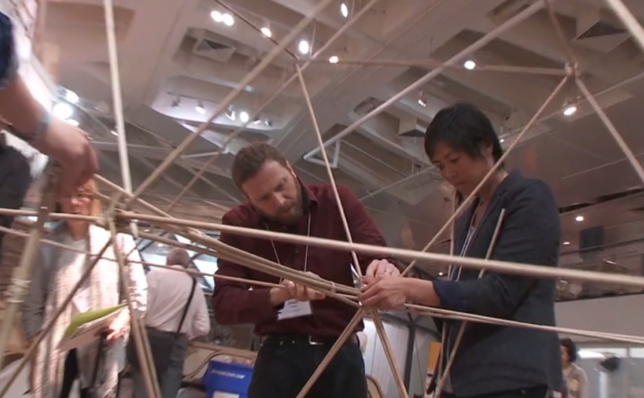
Supporting educators and parents
The examples of math in making experiences shared during the workshop highlighted how successful integration often involves both activity design and skillful facilitation. To play this role well, educators and other adults, such as parents and caregivers, need targeted support—especially if they have narrow views of what constitutes mathematics based on their school experiences. In other words, supporting educators and parents involves not only helping these individuals become better facilitators, but also encouraging them to develop broader and more positive attitudes related to math. As part of this effort, participants agreed that there is a need for more concrete tools, resources, and examples to help educators develop appropriate supports for integrated math-making experiences.

Recommendations for the field
This project was a first step in what we hope is an ongoing, field-wide effort to explore ways of integrating mathematics and other disciplinary content into making and tinkering. Based on discussions before, during, and after the workshop, we offer the following suggestions and possible next steps for the field:

- Work with community members and experts on diversity and inclusion—As participants noted repeatedly, mathematics and making, like all STEM related domains, are inherently culturally situated activities. Integrating these two topics, we believe, has the potential to support a broad range of learners in developing both math and making skills and dispositions that can serve them throughout their lives. However, achieving this potential requires a deep understanding and appreciation for culturally responsive and inclusive approaches to education and learning (e.g., Brown & Crippen, 2017; Garibay, Yalowitz, & Guest Editors, 2015; Gutierrez & Rogoff, 2003; Kirkhart, 1995; National Research Council, 2009). Making time for these discussions, seeking out experts in diversity and inclusion, and partnering with community-based organizations are all important strategies for the field to consider.
- Continue to explore the many aspects of mathematics integral to making and tinkering—Given the breadth of mathematics, an inherent challenge of integrating math and making is to understand the mathematical reasoning and goals potentially at play in a given making or tinkering experience. During the workshop, participants highlighted mathematical domains such as algebraic thinking, spatial reasoning, measurement, and data visualization, as well as reasoning practices and mathematical dispositions. We believe that extended making experiences involving multiple design iterations and testing may be a fruitful place to look for mathematical opportunities, as gathering and evaluating data is both inherently mathematical and consequential for successful design work. Similarly, activities that involve predictable relationships between variables may present an opportunity to highlight functional reasoning.
- Initiate cross-disciplinary collaborations—Successfully integrating mathematics and making requires a deep understanding of mathematics, math education, making and tinkering programs, and more. A promising idea that emerged from the workshop is to initiate collaborative projects involving professionals from across these fields. For example, museums might partner with universities to have “resident mathematicians” help develop and test approaches to integrating mathematics into the museum’s maker activities.
- Advance research on the integration of mathematics and making—This project, not surprisingly, raised more question than answers and suggested many possible directions for future research. For example, project participants continuously raised the question of how best to frame the mathematics in these experiences (e.g., either explicitly or implicitly), and how this framing influences the nature of the experiences, learning outcomes, perceptions and identities related to math, and more. One possible next step for the field is to articulate high priority research questions and then pursue these through cross-institutional research studies, in partnership with making and tinkering educators and math education experts.
- Identify and share concrete examples of integrated math-making experiences—Workshop participants universally agreed that concrete examples are necessary to help educators and researchers understand what it means to integrate mathematics into making and tinkering experiences. Many participants suggested that an important next step for the field would be to share a variety of “case studies,” possibly through an online video library, illustrating successful integrations of math and making. There is a clear need not only to identify and share existing examples, but also to develop and test new approaches.

These recommendations represent just a few of the critical issues and compelling questions that emerged from the project. We invite you to join us in the ongoing pursuit of Math in the Making. Our website, MathInTheMaking.terc.edu, will continue to be updated with writing and resources as our work moves forward.

This material is based upon work supported by the National Science Foundation under Grant No. DRL-1514726. Any opinions, findings, and conclusions or recommendations expressed in this material are those of the authors and do not necessarily reflect the views of the National Science Foundation.

References
Bevan, B., Gutwill, J. P., Petrich, M., & Wilkinson, K. (2015). Learning through STEM-rich tinkering: Findings from a jointly negotiated research project taken up in practice. Science Education, 99(1), 98–120.
Brown, J. C., & Crippen, K. J. (2017). The knowledge and practices of high school science teachers in pursuit of cultural responsiveness. Science Education, 101(1), 99–133.
Dika, S. L., & D’Amico, M. M. (2016). Early experiences and integration in the persistence of first-generation college students in STEM and non-STEM majors. Journal of Research in Science Teaching, 53(3), 368–383.
Garibay, C., Yalowitz, S., & Guest Editors. (2015). Redefining multilingualism in museums: A case for broadening our thinking. Museums & Social Issues, 10(1), 2–7. https://doi.org/10.1179/1559689314Z.00000000028
González, N., Moll, L. C., & Amanti, C. (2005). Funds of knowledge: Theorizing practice in households, communities, and classrooms. Mahwah, NJ: Erlbaum Associates.
Gutierrez, K. D., & Rogoff, B. (2003). Cultural ways of learning: Individual traits or repertoires of practice. Educational Researcher, 32(5), 19–25.
Kirkhart, K. E. (1995). 1994 conference theme: Evaluation and social justice seeking multicultural validity: A postcard from the road. American Journal of Evaluation, 16(1), 1–12.
McCreedy, D., & Dierking, L. D. (2013). Cascading influences: Long-term impacts of informal STEM experiences for girls. Philidelphia, PA: The Franklin Institute Science Museum. Retrieved from https://www.fi.edu/sites/default/files/cascading-influences.pdf
National Council of Teachers of Mathematics. (2000). Principles and standards for school mathematics. Reston, VA: National Council of Teachers of Mathematics.
National Research Council. (2009). Diversity and equity. In Learning science in informal environments: People, places, and pursuits (pp. 209–247). Washington, DC: National Academies Press.
National Research Council. (2012). A framework for K-12 science education: practices, crosscutting concepts, and core ideas. Washington, DC: The National Academies Press.
Pattison, S. A., Rubin, A., & Wright, T. (2016). Mathematics in informal learning environments: A summary of the literature. Retrieved from http://www.informalscience.org/mathematics-informal-learning-environments-summary-literature
Staus, N. L., Falk, J. H., Penuel, W. R., Dierking, L. D., Wyld, J., & Bailey, D. (2016). Using cluster analysis to explore STEM interest pathways in a low income urban community. Manuscript in review.
Turner, S. L., Steward, J. C., & Lapan, R. T. (2004). Family Factors Associated With Sixth-Grade Adolescents’ Math and Science Career Interests. The Career Development Quarterly, 53(1), 41–52.
Vossoughi, S., & Bevan, B. (2014). Making and tinkering: A review of the literature. National Research Council Committee on Out of School Time STEM. Washington, DC: National Research Council, 1–55.
Vossoughi, S., Escudé, M., Kong, F., & Hooper, P. (2013). Tinkering, learning & equity in the after-school setting. In Annual FabLearn Conference. Palo Alto, CA: Standford University. Retrieved from http://www.sesp.northwestern.edu/docs/publications/49224626354098196e0b03.pdf

